PSED
- Circle time hellos games
- To know what they like to do/play with
- To name some of their peers
- To show kind and gentle hands
- Transition between main carer and key person

Expressive arts and Design
- Know that there are different ways to make marks
- To use a range of media to express their feelings
- To join in with actions, movement and dancing.
- To be able to use their body and percussion to make different sounds
- Identify the sound source from a choice of 2 instruments.

Cubs-2-3’s
‘All About Me’
Core texts:
Love Makes a Family - Sophie Beer
Hands Are Not for Hitting - Martine Agassi
Whose Toes are Those? - Jabari Asim


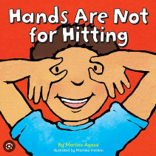
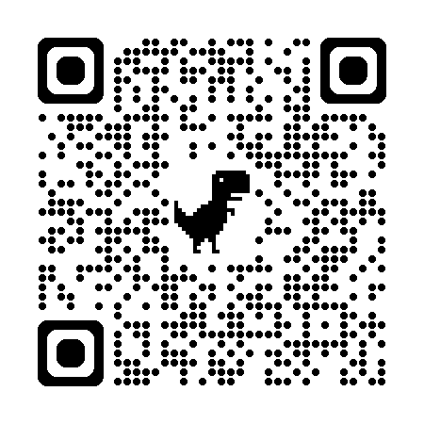
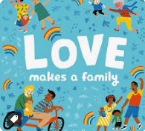
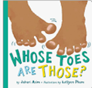
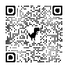
Physical Development
- To run safely on whole foot
- To move in response to music, or rhythms.
- To use cutlery with some control
- To drink from an open cup.
- To hold a pose e.g. standing still in a game.
- To kick a ball with some accuracy.

Literacy
- Use mark making and early writing in their play
- Experiment with mark making in different media
- Listen to stories with some focus

Communication and Language
- To join in with new and familiar rhymes and songs
- Name different emotions
- Name people in their family
- Talk about our features and name body parts.
Maths
- Learn Nursery Rhymes with objects up to 5
- Learn some colour names
- Sort objects by matching colours
- Use numbers in their play e.g. lay table for 2 people

Understanding of the world
- To look for signs of Autumn in the local environment
- To identify and name their family members or important people in their lives
- To begin to talk positively about themselves
- To name objects they see in the outdoor environment

