PSED
- JIGSAW unit ‘Being me in my world’
- Circle time discussions about what makes us special and unique
- To know and understand our school rules
- To name emotions – happy, sad, anger, scared
- Continue to develop friendships with others
- Transition between main carer and key person

Expressive arts and Design
- Know that there are different ways to make marks
- To use a range of media to express their feelings
- To join in with actions, movement and dancing.
- To be able to use their body and percussion instruments to create rhythmic sounds.
- To develop confidence in a variety of role play experiences.

Pre-school
Term 1
‘Me, Myself and I’
Core texts:
Colour Monster
Owl Babies
Giraffes Can’t Dance

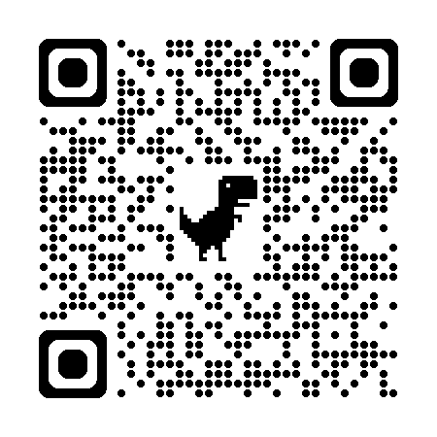
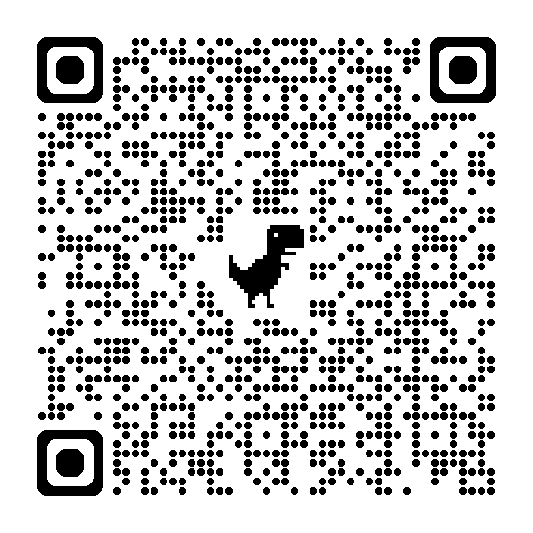
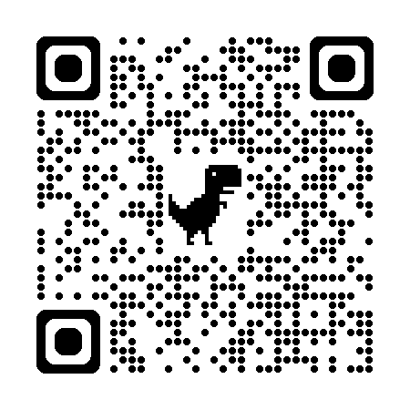
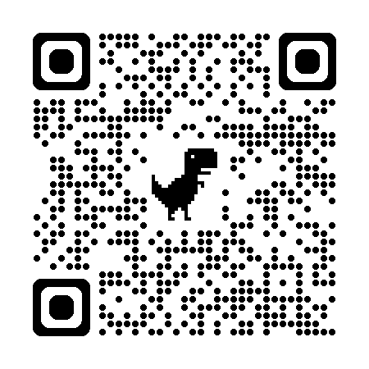
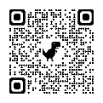
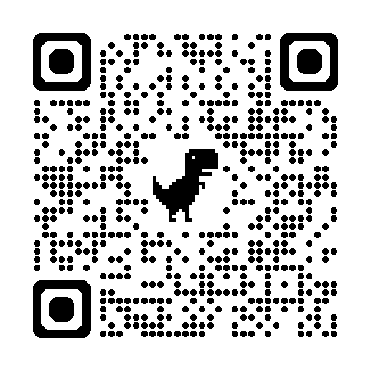
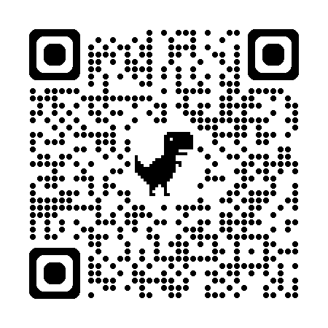
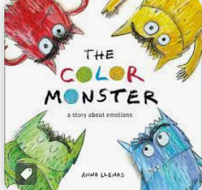
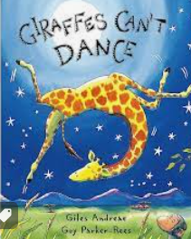
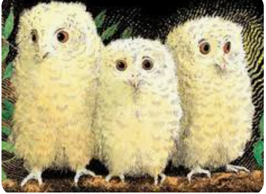
Maths
- To recognise and name colours
- To sort objects by colour
- To continue a simple repeated pattern

Understanding of the world
- To discuss what a Season is and begin to understand how the local environment changes
- To know and look for signs of Autumn in the local environment
- To begin to ask questions and make observations about the world around them
- To be able to describe what they see, hear, and feel whilst outside
- To identify and name their family members or important people in their lives
- To begin to talk positively about themselves
- To begin to understand what Harvest is
Communication and Language
- To identify familiar and favourite stories.
- To join in with new and familiar rhymes and songs
- To begin to join in with repeated refrains
- To begin to answer who, what and where questions
- To continue to use newly taught vocabulary within their play.
Literacy
- Identify favourite stories, rhymes and songs.
Begin to develop an effective pencil grip for mark making.
- Begin to show control when holding, using and manipulating a range of tools and equipment
- Make marks on their picture to stand for their name
- Begin to make marks on a variety of media
- Give meaning to their drawings and paintings
- Use mark making and early writing in their play

Physical Development
- To begin to manage their own self care needs, including toileting, washing hands and putting away their belongings
- To be able to skip, hop, stand on one leg and hold a pose for a game like musical statues.
- To use large muscle movements to wave flags and streamers, paint and make marks.
- To run safely on whole foot
- To move in response to music, or rhythms.

